Frank Muzio

EEB 6485

Weekly Best-practice Commentary #1

Prompt:

Read some papers in a topic of interest to you. Find 1 figure you like a lot, and 1 you dislike, and write a brief explanation (~100 words) for each explaining what works well and what doesn’t for each figure. Be prepared to present this to the class.

Source:

1. Regan, E. C., Santini, L., Ingwall-King, L., Hoffmann, M., Rondinini, C., Symes, A., Taylor, J., & Butchart, S. H. M. (2015). Global Trends in the Status of Bird and Mammal Pollinators. Conservation Letters, 8(6), 397–403. <https://doi.org/10.1111/conl.12162>
2. Julian, 26 G E, Fewell, J. H., Gadau, J., Johnson, R. A., Larrabee, D., Stuart, S. N., Chanson, J. S., Cox, N. A., Young, B. E., Rodrigues, A. S. L., Fischman, D. L., & Waller, R. W. (2002). Status and Trends of Amphibian Declines and Extinctions Worldwide. In Proc. Natl. Acad. Sci. U.S.A (Vol. 99). [www.sciencemag.org/cgi/content/full/306/5702/1780/DC1](http://www.sciencemag.org/cgi/content/full/306/5702/1780/DC1)
3. Figure I like:

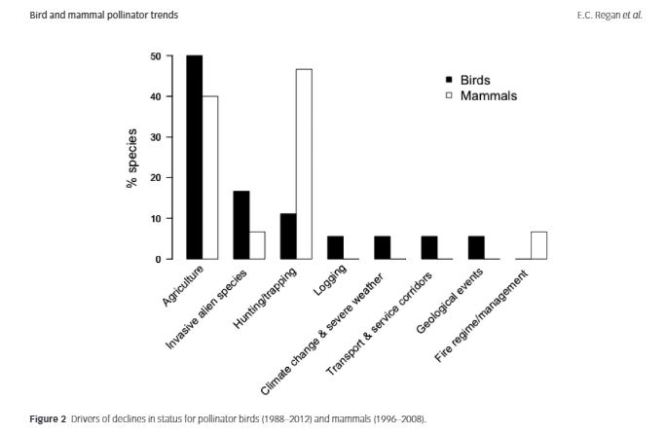

This first figure comes from an article that uses the Red List Index to assess global population trends of pollinating birds and bats. The article was relatively short and only included two figures. This figure above was included to show which drivers were most affecting bird and bat pollinators. I like this figure because it is simple and straightforward. Without much thought, one could quickly look at this figure and understand the important points (i.e. Agriculture is a key driver in the declines of both birds and bats). The one downfall of this figure is that it is not very aesthetically pleasing. It doesn't really catch your eye or draw you in, it's just a simple black and white bar graph.

1. Figure I don't like:

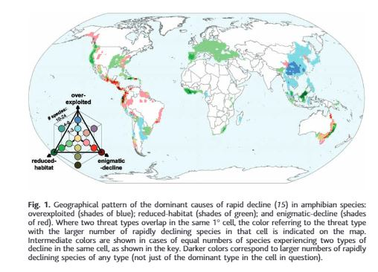

This second figure comes from a paper that discusses the global trends of all extant amphibian species. They included this graph to show areas of rapid decline across the globe due to three different causes: 1) reduced habitat, 2) over-exploitation, 3) enigmatic decline. First off I think this graph has a lot of potential and I can see why they included it. It is attractive and draws you in. My problem with it is the clarity and confusion caused by the colors and size. I think for the detail in this graph, it was presented much too small. It is very hard to see and discern between different colors. The legend in the corner makes sense but it takes some time to grasp how to use it. Also all the colors could be very difficult for anyone who has issues with color blindness.